Blended-Mode
Master of Technology
(M. Tech.) Program

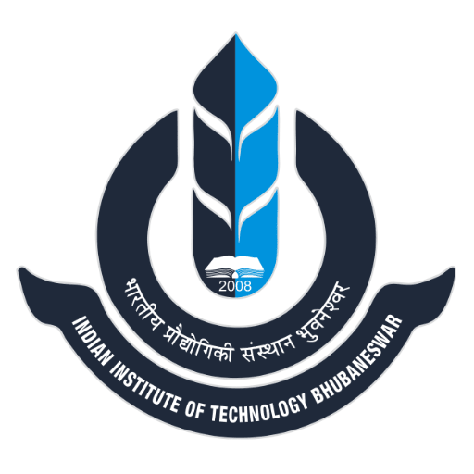

INDIAN INSTITUTE OF TECHNOLOGY BHUBANESWAR

REGULATIONS FOR
Blended-Mode Master of Technology (M. Tech.) Program for Working Professionals
- GENERAL
The Institute will provide User Oriented Master of Technology (M.Tech) Programs through blended-mode (i.e., online plus in-person) for professionals from industries and other organizations. The rigor of this blended program will be at par with regular M.Tech Program. This program is intended for expertise building in a specific domain and upskilling of industry people. Faculties of the Institute and group of Industries can propose certain M.Tech program. The courses and the project work (in the specific package) can be of interdisciplinary nature. Through this program, the interaction of faculty members with industry engineers will increase in multiple areas. Needless to mention, it shall provide a valuable experience about the ways of solving industry problems.

- DURATION OF PROGRAM
The program is self-paced so that candidates can have flexibility in completing the program in 2-5 years. The program can be pursued in the hybrid-mode i.e., through video-enabled online courses and at the campus. Lectures will be scheduled typically at evening and weekends.

- ELIGIBILITY CRITERIA FOR ADMISSION
3.1 Same as Regular M.Tech., GATE score is not mandatory.
3.2 An additional eligibility criterion may be added in terms of work experience, disciplines, etc., in case a particular program requires.

- ADMISSION
4.1 Admission shall be carried out once in a year: in the Autumn Semester.
4.2 The candidates either sponsored by the organization or they can apply as self-sponsored. All candidates for admission to the program will be required to submit their online applications in the prescribed format together with self-attested copies of relevant testimonials, No Objection Certificate (NOC) from the employer and prescribed fees by such date as notified by the Institute.
4.3 Shortlisting Criteria
Shortlisting will be done based on B.E/B.Tech marks.
-1-

4.4 Selection Procedure:
Shortlisted candidates will have to appear for the interview (in-person) and selection process will be based on the performance during the interview.
In case of an inter-disciplinary program (involving two or more Schools), the selection process will be regulated by the committee nominated by Dean (PGRP). If the program is offered by particular School, then selection process will be regulated by the concerned School.
4.5 Dean (PGRP) after due approval process, shall issue the offer of admission to the applicant(s) in the Blended-mode M.Tech program. The students will be required to join the program (remotely or in-person) on the date of registration.
4.6 Selected students shall be enrolled for the program only after they have paid all prescribed fees and dues.

- RESIDENCE, ATTENDANCE AND DISCIPLINE
5.1 Residence Requirement: There will be no residence requirement at the campus, though the facilities at Institute can be used on a payment basis if needed for the project.
5.2 Attendance in the class is compulsory.
5.3 The students will be subject to all rules regarding conduct and discipline as applicable to regular M.Tech. students.

6. COURSE STRUCTURE
6.1 Course structure shall be same as for a regular M.Tech. Program at IIT Bhubaneswar.
6.2 On completion of every course, the candidate will be given “Course Completion Certificate”.
6.3 A candidate shall be required to choose a Thesis Supervisor at the Institute for guidance in project work. Candidate can choose Thesis Supervisor during the course work through mutual discussion with faculty member of the Institute. A joint supervisor (i.e. Co-Supervisor) with appropriate qualifications/industry experience can also be added from industry after due consideration and approval by the Institute.
6.4 The project work is to be pursued in the industry (parent organization) completely. But if the industry/organization does not have the facilities required for the project work then project (or part of the project) can be done at the Institute, provided those facilities exist. In any case, project has to be directly “related” (or should be of relevance) to the industry that sponsors the candidate.

-2-
- Mode of Lectures and laboratory experiments
It is proposed to hold the lectures/laboratories in blended (hybrid) mode, in the late evening hours on working days and/or on weekends, in slots notified in advance. Students may be required to come to campus to conduct the laboratories during a certain specified period.

8. examination
Student shall have to appear in the examinations in-person at the campus. All other regulations with regard to examination shall be same as that of regular MTech. Program.

- grading and THESIS / project evaluation
The procedure for Grading and Thesis evaluation shall be same as that of regular MTech. Program.

10. Fee structure
The fees related to registration of courses every semester will be decided by the Institute.
-3-

